**AI Algorithm - 1002-01**

**SOW-2.1**

**PROJECT TITLE: Flight fare Prediction**

**Project Team**

|  |  |  |
| --- | --- | --- |
| **Student_ID** | **Name** | **Project Role** |
| 100833169 | Vaibhavi Thakkar | UI,Business logic |

**Revision History**

|  |  |  |  |
| --- | --- | --- | --- |
| **Version** | **Description** | **Author** | **Approver** |
| **1.0** | **SOW1** | **Project Team** | **Marcos** |
| **1.1** | **SOW2** | **Project Team** | **Marcos** |

Table of Contents

**1.1 SCOPE** 3

**1.2 OBJECTIVE OF THE REQUIREMENTS** 3

**1.3 PROBLEM STATEMENT** 3

**1.4 DETAILED REQUIREMENTS** 3

**1.4.1 TASKS, ACTIVTIES, DELIVERABLES AND MILESTONES (WBS)** 3

**1.4.2 DIFFERENT MODELLING APPROACH...................................................................................**5

**1.5 TECHNICAL AND OPERATIONAL ENVIRONMENT** 5

**1.6 ACCEPTANCE CRITERIA** 5

**1.7 PROJECT MANAGEMENT CONTROL PROCEFDURES** 5

**1.8 CHANGE MANAGEMENT PROCESS** 5

**Authorization:** 6

# **1.1 SCOPE**

To detect fare of future flights based on historical data.To get all the past flight travel data and generate the report detecting the future flight price based on source and destination entered,

# **1.2 OBJECTIVE OF THE REQUIREMENTS**

Flights are the easy means of transportation and to be able to deliver flight fare price detection for the future flight traveling through same source and destination.Fetch the historical data and based on available past data generate report. A flight price help the customer to book the flight on prior to save money.

# **1.3 PROBLEM STATEMENT**

* Inefficient search results based on selected criteria’s
* Fluctuation in price value.
* Inaccurate data mining algorithms (Elementary frameworks)
* Limited functionality like booking flight and checking availability of flights

# **1.4 DETAILED REQUIREMENTS**

* A customer will have an ability to enter source and destination other filter criteria to get the desired result set.
* A customer can change the transit location to view difference in price based on source and destination..

## **1.4.1 TASKS, ACTIVTIES, DELIVERABLES AND MILESTONES (WBS)**

* Fetch the Historical data from different sources like indigo,spicejet and other resources
* Perform EDA on obtained final filtered data set
* Mining of data
* Analysis of difference algorithms and performing trial and error.
* Finalizing the algorithm based on different model analysis.

## **1.4.2 Database : Details of flights traveling from source to destination**

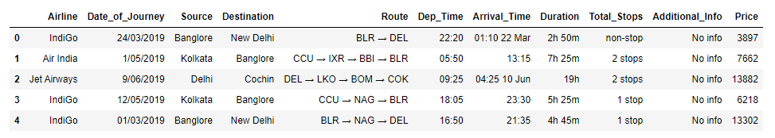

## **1.4.3 Airline Train Data-set**

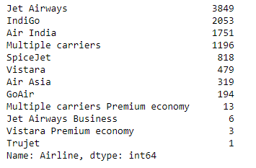

## **1.4.4 Graph Visualization**

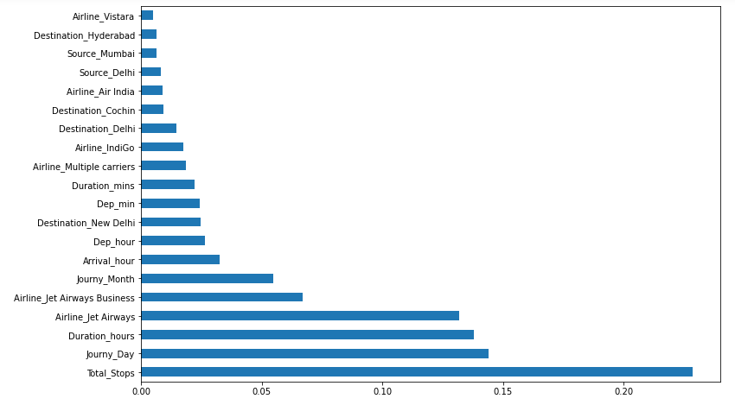

## **1.4.5 Scatter Graph**

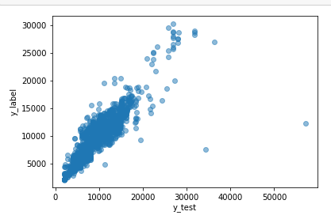

## **1.4.6 DIFFERENT MODEELLING APPROACH**

Checked the accuracy of data with different modelling approach and below are the accuracy results.

1. **Linear Regression:**

For train data accuracy : 62.4% For test data accuracy: 61.95%

1. **Decision Tree:**

For train data accuracy : 96.9% For test data accuracy: 72.8%

1. **Random Forest Search:**

For train data accuracy : 95.37% For test data accuracy: 79.73%

Based on checking on testing and training data it can be concluded that Random forest search approach gives better accurate result and will be considered for final model.

## **1.5 TECHNICAL AND OPERATIONAL ENVIRONMENT**

* GIT
* Sublime IDE
* Jupyter Notebook / Google Colab /PyCharm
* Postgressql
* AWS

# **1.6 ACCEPTANCE CRITERIA**

* Developed algorithm will fetch comparatively accurate result set. Users should be able to navigate the application with the help of interactive UI/UX design.
* Price detection will help customer to prioritize the flight booking based on data input and processed output.

# **1.7 PROJECT MANAGEMENT CONTROL PROCEFDURES**

* Update to the professor on the progress until project delivery date
* Fortnightly internal meeting to track the project progress until project delivery date

# **1.8 CHANGE MANAGEMENT PROCESS**

* Any changes to SOW shall be discussed within the team for its feasibility before seeking the professor’s approval
* Any agreed changes within the team shall not be made in SOW unless approved by the professor.

# **Authorization:**

This scope has been authorized and approved.

------------------------------------------------------------------

Date and Signature